Lab 1 – Starting with Unity



2026/2027
UC: Desenvolvimento de Videojogos
Henrique Raimundo
Rodrigo Castanheira

Setúbal,
ESTSetúbal

Index
Contents
Level 1- 3
TextMeshPro - Text (UI): 3
Signed Distance Field 4
RectTransform 4
Image 5
Button 5
Level 2 6
Level 3 6
Level 4 7

Level 1-

TextMeshPro - Text (UI):
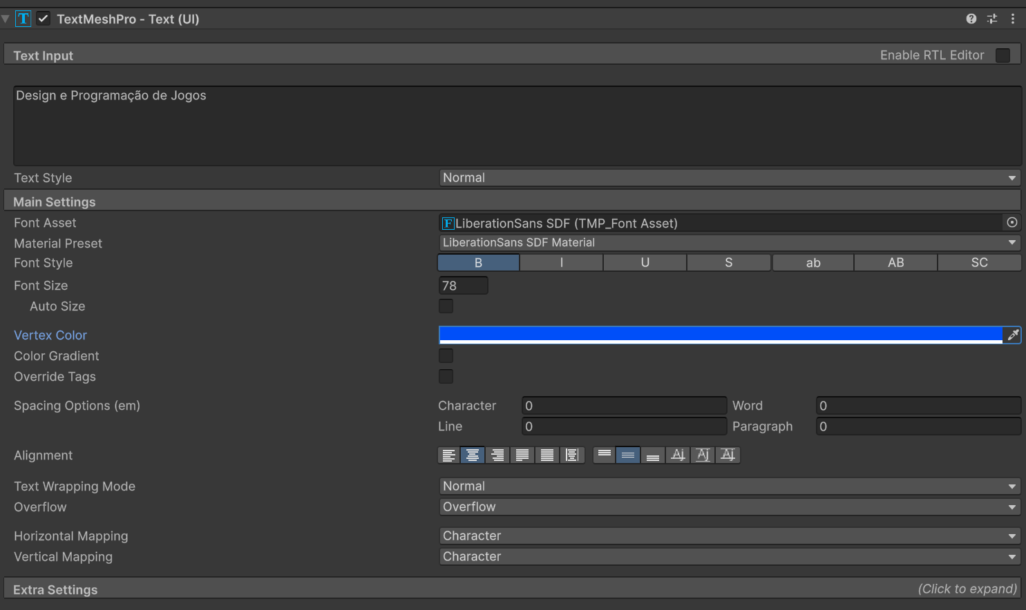
TMP also allows to precisely adjust spacing between characters, words, lines and paragraphs.

Signed Distance Field
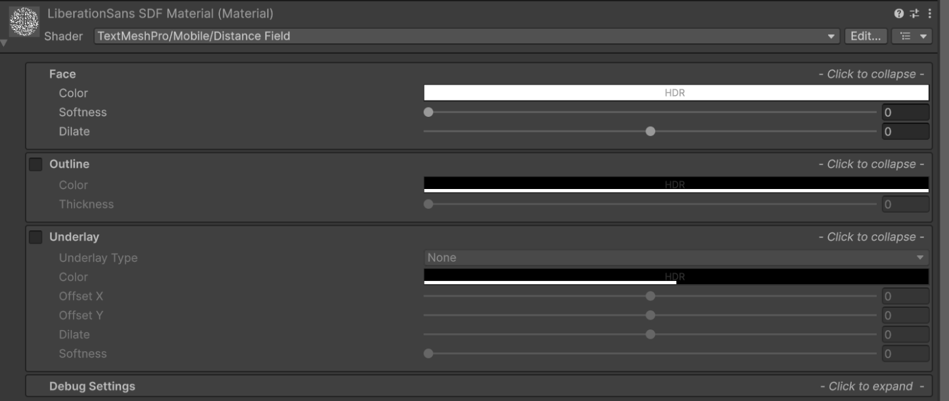
(SDF) is a unity system that renders text at high resolutions without losing any quality.

RectTransform
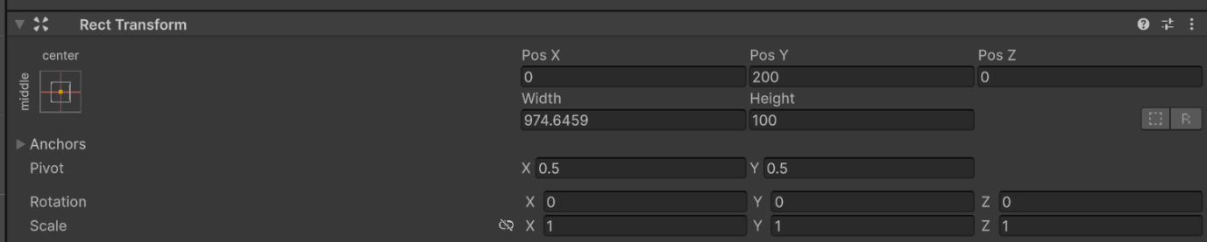
RectTransforms are used for GUI but can also be used for other things. It's used to store and manipulate the position, size, and anchoring of a rectangle and supports various forms of scaling based on a parent RectTransform.

Image
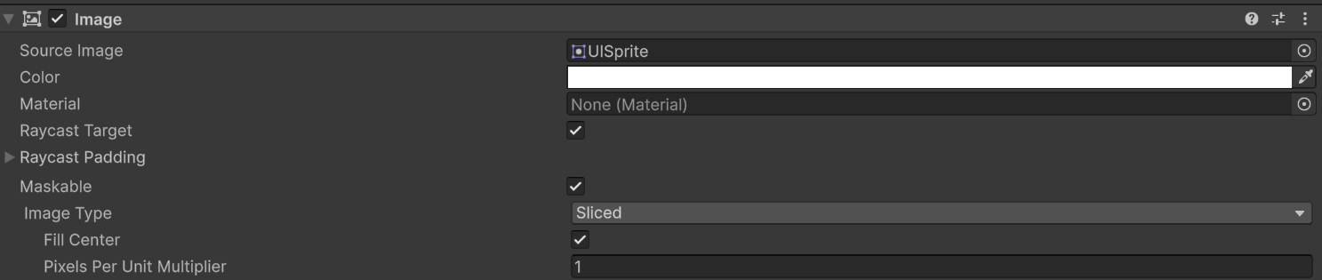
The Image control displays a non-interactive image to the user. You can use this for purposes such as decorations or icons, and you can change the image from a script to reflect changes in other controls. The control is similar to the Raw Image control but offers more options for animating the image and accurately filling the control rectangle. However, the Image control requires its Texture to be a Sprite, while the Raw Image can accept any Texture.

Button
The button is designed to initiate an action when the user clicks and releases it. If the mouse is moved off the button control before the click is released, the action does not take place.
The button has a single event called On Click that responds when the user completes a click. Typical use cases include:
- Confirming a decision (eg, starting gameplay or saving a game)
- Moving to a sub-menu in a GUI
- Cancelling an action in progress (eg, downloading a new scene)
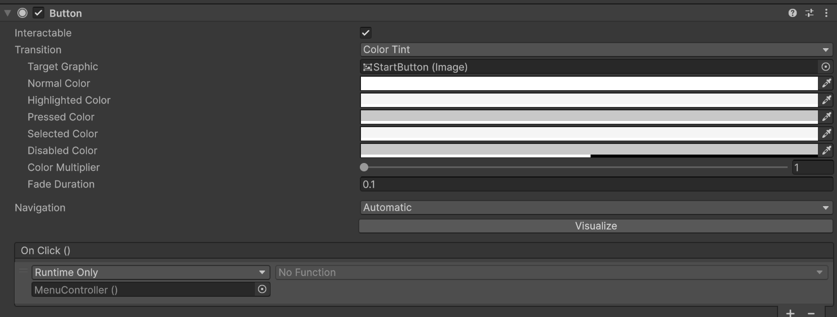

Level 2
On the code collectible.cs it starts by defining two variables.
The first one being an Int variable named “scoreValue” and its set on one, the second one being a bool type named “destroyOnCollect” and its set on true.
It was created a private void function named “OnTriggerEnter2D” that uses the collider2D argument named “collision”.
Inside it is a condition controller “if” that validates if the instance is different than null.
If the condition is verified the instance will add a value to the variable “scoreValue”, if the condition is not verified a debug will run warning the user that the gamemanager is not found on the scene, and that the user needs to verify if the gamemanager has a script attached to it.

There is also another “If” condition, if the bool variable “destroyOnCollect” is verified, the game object will be destroyed, if not verified, it will just be inactive, and it can be used again.

Level 3
There is 3 different types of bodys on unity they are dynamic, kinematic and static.
The dynamic bodys they are affect by physiques (gravity, vectors, other bodys) usually used on players, enemys and projectiles.
The kinematic bodys have physiques but are not affected by external physiques, for example gravity and other bodys but can be controlled through coding (for example vectors), usually used on games that don’t use gravity for example pokemon NPC’s, but can also be used on players.
The Static bodys don’t interact with any type of physique, usually used for the environment.

Level 4
Firstly we started by painting a map on a tilemap with various types of sprites.
After that our task was to create a collectible, we started by choosing a sprite of a blue bottle, an empty game object was created inside a grid and assigned with the blue bottle sprite, it was also added to the inspector a new component named “Collectible(script)”, It was also added a box collider 2D, it is set to the bottle size and set to trigger so that when the player touches it, it can be picked up, the script that was assigned to it makes It so that the player can pick it up and add points to a score value.
Then the gameobject of the bottle(collectable) was dragged to the prefab folder, making it so that we can use the same item multiple times.
An empty gameobject was created, it was assigned with some components for example the sprite renderer that allows us to add sprites to the gameobject, rigidbody2D that applies gravity to the gameobject, the Freeze rotation(Z) checkbox is checked so the player can’t rotate sideways, it was also added the BoxCollider2D that allows the player to have a hitbox, that way the player won’t fall through the map, then lastly the script “playercontrol” was added, it allows us to choose the character movement speed, its jump force, a space to add a groundcheck, we can also change the groundcheck radius and choose what layer the ground is, also allows us as an optional setting to activate a double jump and a groundcheck.
The “player” tag was added to the player gameobject.

For the character to be able to jump he needs to be grounded, for that we created an empty gameobject, we positioned it under the playable character and associated it inside the player script, it checks if the player is touching any gameobject with a ground layer.
The UI is a very important part of any game, we created a canvas named “Score”, it was set to screen space – overlay, it makes it so its always on the screen, inside it we created a TextMeshPro, for it to work a empty

gameobject was created just to use the “game manager” script, the TMP was attached to it, each time we pick a collectible a variable will be updated and showed on the text.
Next we created a respawn point, firstly we created an empty gameobject named “Respawn Trigger” with a BoxCollider2D and expanded it across the bottom of the map, then we associated the script “simple respawn” to it, it will use the “death” tag and is set to “Is trigger”.
After that we created another empty gameobject named “Respawn point” it will not have anything attached to it, it was positioned on the start of the map and associated inside the “simple respawn”, each time the player falls from the map, the player will touch the trigger, its coordinates get moved to the respawn point location
Lastly we went back to the main menu and tested; everything works as it should.

